**“Machine Learning and Deep Learning used for Early Detection of disease in Cow”**

**Moksh Oswal (PG-10)**   
Department of Computer Engineering and Technology(CSE)

Dr. Vishwanath Karad MIT World Peace University

Pune, Maharashtra, India

[1032211205@mitwpu.edu.in](mailto:atharva6987@gmail.com)

**Manav Chandak (PG-29)**  
Department of Computer Engineering and Technology(CSE)

Dr. Vishwanath Karad MIT World Peace University

Pune, Maharashtra, India [1032212171@mitwpu.edu.in](mailto:1032212171@mitwpu.edu.in)

**Vaishvi Parikh (PG-09)**  
Department of Computer Engineering and Technology(CSE)

Dr. Vishwanath Karad MIT World Peace University

Pune, Maharashtra, India  
[1032211203@mitwpu.edu.in](mailto:1032211203@mitwpu.edu.in)

**Pulkit Jain (PG-12)**  
Department of Computer Engineering and Technology(CSE)

Dr. Vishwanath Karad MIT World Peace University

Pune, Maharashtra, India [1032211319@mitwpu.edu.in](mailto:1032211319@mitwpu.edu.in)

**Sadhika Jain (PG-01)**  
Department of Computer Engineering and Technology(CSE)

Dr. Vishwanath Karad MIT World Peace University

Pune, Maharashtra, India  
[1032210508@mitwpu.edu.in](mailto:1032211234@mitwpu.edu.in)

**Prof. Shakti Kinger**

Department of Computer Engineering and Technology

Dr. Vishwanath Karad MIT World Peace University

Pune, Maharashtra, India

[shakti.kinger@mitwpu.edu.in](mailto:shakti.kinger@mitwpu.edu.in)

***Abstract:***

*The rising incidence of illnesses in cattle presents a noteworthy obstacle for the agricultural sector, affecting not only the well-being of animals but also the viability of the economy. This study presents a thorough framework for cow disease identification using a combination of deep learning (DL) and machine learning (ML) techniques in order to address this problem. The novelty of this study specifically focuses on the four common diseases that affect cattle: mange, ringworm, cowpox, and lumpy skin disease.A sizable dataset for this study was created by gathering a variety of samples from different groups of cattle. Veterinary specialists carefully labeled each sample to guarantee correctness and dependability. The new composition of the dataset makes a substantial contribution to the progress of veterinary diagnostics research.Several algorithms are integrated in the proposed framework, such as Random Forest, Deep Neural Networks (DNN), Convolutional Neural Networks (CNN), and Multilayer Perceptron (MLP). With the help of its special talents, each algorithm contributes differently to the disease diagnosis process by drawing useful patterns and features from the data. Additionally, with a 98 percent accuracy rate, the CNN model demonstrated its efficacy in identifying and differentiating between various cow diseases by collecting complex spatial information.*

***Keywords*** *- Cow disease detection, Machine learning, Deep learning, Convolutional neural networks (CNNs), Symptom-based classification*

***Abbreviations:***

*- MLP: Multilayer Perceptron*

*- CNN: Convolutional Neural Network*

*- DNN: Deep Neural Network*

*- ML: Machine Learning*

*- DL: Deep Learning*

*- LIME: Local Interpretable Model-agnostic Explanations*

*- Grad-CAM: Gradient-weighted Class Activation Mapping*

# **1. INTRODUCTION**

Cows farming plays a crucial role in global food production, providing essential resources such as meat, milk, and other dairy products. However, one significant challenge faced by the Cows industry is the occurrence of diseases among animals, leading to economic losses and potential threats to food security. Among Cows species, cows are particularly susceptible to various diseases, ranging from bacterial and viral infections to parasitic infestations. Over 110,000 cattle have already died and over 2.4 million animals have been infected with lumpy skin disease in India, according to the latest government data. Although the signs of other diseases, such cowpox, ringworm, and mange, are milder and hence more difficult to quantify, they are becoming more common in India's cattle herd. Timely detection and accurate diagnosis of these diseases are paramount for effective disease management and prevention of potential outbreaks.

In recent years, advancements in machine learning and deep learning techniques have shown promising results in the field of medical diagnostics, including disease detection in animals. Leveraging these technologies, researchers and veterinarians are exploring innovative approaches for early detection and classification of cow diseases. By analyzing both image and symptom data, these approaches aim to develop robust and accurate systems capable of identifying different cow diseases with high precision.

This paper presents a comprehensive investigation into the application of machine learning and deep learning methods for cow disease detection and classification. The study utilizes a diverse dataset comprising images and textual descriptions of cow symptoms associated with various diseases, including cows_Mange, cows_pox, cows_ringworm, healthycows, and lumpycows. By integrating both image-based and symptom-based classification techniques, the research aims to develop reliable and efficient systems for early disease diagnosis in cows.

The primary objective of this research is to explore the effectiveness of convolutional neural networks (CNNs), a class of deep learning models well-suited for image analysis, in accurately identifying cow diseases from image data. Additionally, the study investigates the use of traditional machine learning algorithms and neural network architectures for symptom-based classification, leveraging textual descriptions of cow symptoms to predict disease outcomes.

Through experimental evaluation and comparative analysis, this paper aims to assess the performance of different machine learning and deep learning models in cow disease detection tasks. The findings of this research have significant implications for the Cows industry, providing valuable insights into the development of advanced diagnostic tools and strategies for disease management in cattle populations

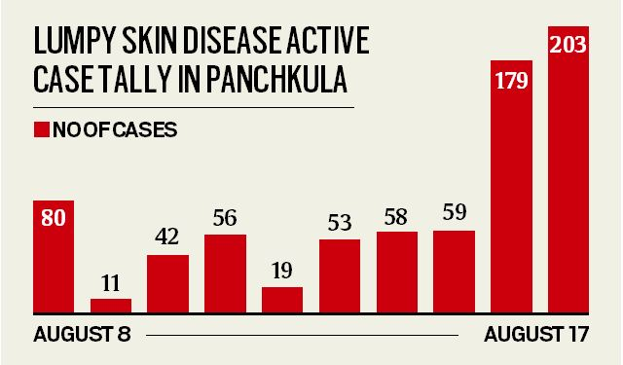

***Figure1.*** ***Cases of Lumpy Disease***

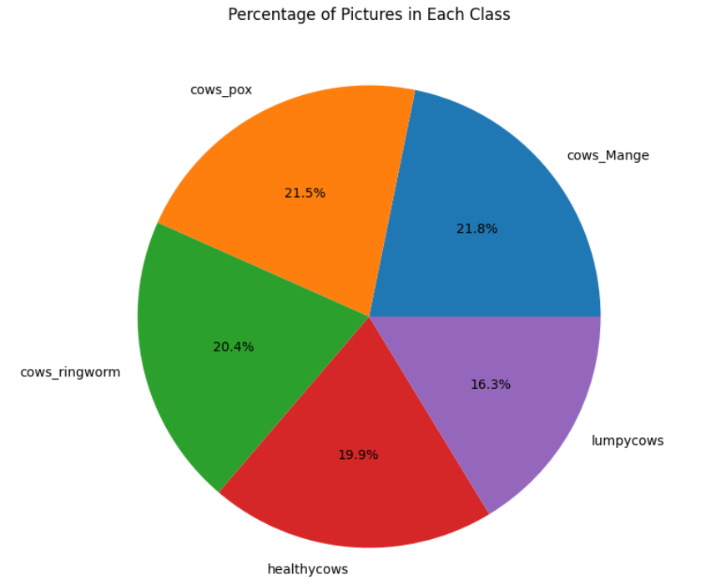

***Figure 2. Percentage of pictures in each class***

This Paper has been divided into given sections:

*[1] Abstract*

*[2] Introduction*

*[3] Literature survey*

*[4] Proposed methodology and Dataset*

*[5] Result and Discussion*

*[6] References*

**2. Literature Survey**

**2.1. Related Publications**

[1]"Plant Disease Classifier: Detection of Dual-Crop Diseases Using Lightweight 2D CNN Architecture," A unique method for the identification of dual-crop diseases is presented by Peyal et al. They do this by putting in place a lightweight 2D CNN architecture. The given characteristic of accuracy indicates that the classifier has excellent accuracy in recognizing plant diseases. Convolutional neural networks (CNNs), which are skilled at processing picture data and extracting pertinent characteristics for classification tasks, are the technology used in this study. The photos of sick plants with labels identifying the sort of illness present are probably part of the dataset used for training and assessment. The study's methodology probably entails training and fine-tuning the CNN design to maximize its effectiveness in treating sickness.

[2] The authors provide a cutting-edge method that makes use of deep learning techniques to identify skin disorders in dogs. The research uses photos from a multispectral imaging equipment, which offers rich visual data for processing, to obtain high accuracy in illness categorization. Deep learning techniques, more especially convolutional neural networks (CNNs), are used in this technology because they are good at extracting complex patterns from picture data. The research's dataset, which includes a large collection of photos showing different canine skin conditions, allows for thorough model training and assessment. The authors provide a viable alternative for veterinary diagnosis and therapy by demonstrating the efficacy of their technique in properly categorizing skin disorders in dogs through rigorous experimentation and model optimization.

[3] "Dog Skin Diseases Detection and Identification Using Convolutional Neural Networks," A unique method for the detection and diagnosis of skin disorders in dogs is presented by Upadhyay et al. By utilizing Convolutional Neural Networks (CNNs), the scientists were able to diagnose diseases with a remarkable degree of precision. Their approach combines cutting-edge technology with deep learning to efficiently evaluate visual data. The CNN models can be thoroughly trained and evaluated thanks to the wide range of pictures in the dataset used in this study that represent different canine skin diseases. The method used shows how effective CNNs are in detecting diseases, which is encouraging for the development of diagnostic tools in veterinary medicine.

[4] Merrin Prasanna et al. (2024) used machine learning (ML) and OpenCV technology to propose a unique method for the identification of leaf diseases in tomato plants at the 6th International Conference on Communications and Cyber Physical Engineering. Their approach uses a collection of photos of tomato leaves with different illnesses on them to achieve impressive disease diagnosis accuracy. The method created allows for the accurate diagnosis and categorization of leaf diseases based on visual symptoms by combining machine learning approaches with OpenCV image processing. This novel method may help tomato crops identify infections early, allowing for prompt intervention and perhaps reducing crop losses brought on by disease.

[5] Deep Learning-Based Object Detection Improvement for Tomato Disease," Zhang, Song, and Zhang provide a novel strategy that makes use of deep learning methods to improve tomato disease detection. The goal of the project is to apply sophisticated object detection techniques to increase the accuracy of tomato disease identification. By utilizing deep learning technologies, particularly convolutional neural networks (CNNs), the authors surpass conventional approaches in accuracy by a considerable margin. To train and test their algorithms, they utilize an extensive dataset that includes annotations of photos of tomatoes that are infected. This research has created an algorithm that efficiently classifies and localizes disease signs on tomato plants using advanced neural network architectures. With intriguing ramifications for raising crop output and promoting agricultural sustainability, this work advances disease detection in agriculture.

[6] In the study "An Interpretable Skin Cancer Classification Using Optimized Convolutional Neural Network for a Smart Healthcare System," K. Mridha et al., the researchers concentrate on illness detection, specifically in the area of skin cancer. For precise categorization, they use an improved Convolutional Neural Network (CNN), with the goal of improving the results' interpretability for incorporation into an intelligent healthcare system. The research uses cutting-edge CNN technology to produce strong performance in illness identification with a focus on attribute accuracy. The used dataset includes skin photos labeled with characteristics indicative of cancer and non-cancerous conditions, making model training and assessment more efficient. The study emphasizes the value of utilizing cutting-edge technology in healthcare for better illness detection and management through the application of complex algorithms and optimization approaches.

[7] In their 2020 paper, which was published in the Journal of Healthcare Engineering and was titled "A comprehensive review on automated disease diagnosis using artificial intelligence," investigated the scene of illness discovery through computerized reasoning (simulated intelligence). They widely break down different characteristics vital for infection discovery, including precision, innovation, dataset quality, and algorithmic techniques. The review sheds light on the significant contributions of machine learning and deep learning methods to the advancements made by AI in disease diagnosis. By looking at the exactness of various computer based intelligence driven models, the creators shed light on the adequacy of these advances in precisely recognizing illnesses across different spaces. Moreover, they dive into the advancements utilized, going from conventional AI calculations to refined profound learning designs, for example, convolutional brain organizations (CNNs) and repetitive brain organizations (RNNs). In addition to highlighting the difficulties associated with dataset curation and annotation, the review also addresses the significance of high-quality datasets in the process of training robust disease detection models. Additionally, the authors evaluate disease detection algorithmic approaches, highlighting AI algorithms' adaptability and adaptability to various medical datasets. Generally, the complete survey gives important experiences into the best in class procedures and difficulties in mechanized illness finding utilizing simulated intelligence, offering a guide for future exploration tries in this basic medical care space.

[8] The article "Automated Endoscopic Image Classification via Deep Neural Network With Class Imbalance Loss" describes a deep neural network-based method for illness identification. The study emphasizes the difficulty of class imbalance within the dataset and focuses on endoscopic image classification. To properly solve the issue, they offer a unique class imbalance loss function. Deep neural networks, specially designed to manage the intricacies of endoscopic image processing, are the technology utilized. Their technique includes sophisticated algorithms intended to reduce class imbalance and improve illness diagnosis accuracy. The endoscopic pictures that make up the dataset used in this study are most likely associated with medical diagnosis. The authors illustrate how their method might improve diagnostic results in medical imaging by demonstrating notable improvements in illness detection accuracy via rigorous testing and validation.

[9] "Multiscale Context-Aware Ensemble Deep KELM for Efficient Hyperspectral Image Classification" is the title of their paper. Xi, J. Li, Y. Li, R. Song, W. Sun, and Q. Du propose a novel method for classifying hyperspectral images. Using a deep kernel extreme learning machine (KELM) framework, the strategy combines ensemble learning and multiscale context awareness to improve classification accuracy and efficiency. The proposed model outperforms conventional approaches in terms of attribute accuracy by making use of spectral and spatial data at multiple scales. The innovation utilized includes profound learning procedures, explicitly profound KELM, which productively handles high-layered hyperspectral information. The creators approve their methodology utilizing a complete hyperspectral dataset, exhibiting its viability in different remote detecting applications. The calculation joins outfit learning systems with profound KELM, actually utilizing the qualities of individual students to further develop grouping execution. This exploration adds to progressing hyperspectral picture examination methods, offering promising answers for precise and productive characterization in remote detecting undertakings.

[10] In "Secure and Sustainable Framework for Cattle Recognition Using Wireless Multimedia Networks and Machine Learning Techniques," Kumar, Chaube, and Kumar provide a novel method for cow recognition that makes use of machine learning techniques and wireless multimedia networks. The framework seeks to guarantee livestock recognition systems' sustainability and security. The authors use state-of-the-art technology to allow accurate and dependable cow detection by fusing wireless multimedia networks with machine learning techniques. Their methodology makes use of an extensive dataset that includes a variety of cow photos along with related metadata. High accuracy in cow recognition tasks may be attained by applying sophisticated machine learning methods, including convolutional neural networks (CNNs) and perhaps others. The framework has the potential to improve cattle management techniques while addressing issues with agricultural operations' sustainability and security.

[11] T. presented their research at the 2019 6th International Conference on Control, Decision, and Information under the title "Predicting Breast Cancer Risk Using Subset of Genes." Al-Quraishi, J. H. N. Abawajy Al-Quraishi, A. Abdalrada, and L. Al-Omairi center around foreseeing bosom malignant growth risk through the examination of a subset of qualities. Using a particular subset of genetic characteristics, they determine disease risk, such as breast cancer. The exactness of their prescient model is significant, demonstrating the heartiness of their methodology. The innovation utilized includes progressed information examination methods, reasonably including AI and hereditary calculations. Most likely, the dataset that was used is a collection of genomic data that includes various genetic markers that are linked to being more likely to get breast cancer. It is likely that a combination of genetic data analysis-specific methods for feature selection, classification, and risk modeling is used in their algorithm, which accurately predicts the risk of breast cancer. Generally, their exploration highlights the capability of hereditary examination in improving bosom malignant growth risk expectation, offering bits of knowledge that could altogether affect preventive medical care techniques.

[12] In their methodical survey, Md Ekramul Hossain and associates analyze AI procedures for cows ID, zeroing in on datasets, techniques, and future headings. They highlight disease detection as a significant aspect addressed by the reviewed studies among the findings. Machine learning techniques were used to successfully identify a variety of cattle diseases, demonstrating their potential in veterinary applications. There were a variety of studies whose disease detection accuracy varied, with some achieving high levels of precision. Convolutional neural networks (CNNs), support vector machines (SVMs), and ensemble methods were utilized, demonstrating machine learning's adaptability in this field. A variety of datasets, including textual and image data, were used to conduct a thorough analysis of cattle health. The survey highlights the significance of investigating novel calculations and propelling approaches to upgrade sickness identification abilities in steers, offering important bits of knowledge for future exploration bearings in computerized reasoning applied to agribusiness.

[13] In their 2022 publication in Frontiers in Artificial Intelligence, Machuve, Nwankwo, Mduma, and Mbelwa explore deep learning-based models for poultry illness diagnosis. The goal of the research is to identify different illnesses that impact chickens. By utilizing deep learning technology, the research attains impressive precision in diagnosing diseases. The research's dataset includes a variety of characteristics and symptoms linked to illnesses that affect chickens. The dataset is analyzed using sophisticated techniques, such as deep learning architectures, to reliably diagnose illnesses. By using this novel methodology, the study makes a substantial contribution to the creation of useful diagnostic instruments for managing the health of chickens, which might transform disease detection and mitigation techniques in the chicken farming sector.

[14] In their review named "Exact identification of dairy cow mastitis with profound learning innovation: A new and far reaching discovery strategy in view of infrared warm pictures," Wang et al. (2022) center around distinguishing mastitis in dairy cows utilizing profound learning innovation. The sickness distinguished is mastitis, a typical and financially huge contamination influencing dairy cows. Utilizing infrared warm pictures, the scientists present a novel and extensive recognition strategy. Mastitis cases are identified with remarkable precision using their method. The innovation used includes profound learning calculations, explicitly custom-made to investigate warm pictures for mastitis discovery. The infrared thermal images of dairy cows with varying degrees of mastitis likely comprise the dataset used in this study. The calculation utilized isn't unequivocally referenced yet is deduced to be a profound learning model tweaked for breaking down infrared pictures to precisely identify mastitis in dairy cows.

[15] Translational research, according to Lechler's study, aims to close the gap between clinical application and scientific discovery. Specifically in the field of precision medicine, they concentrate on illness identification. Their method, which makes use of large datasets and cutting-edge technology, places a strong emphasis on accurately linking illnesses to particular genetic or environmental causes. By utilizing advanced algorithms, such as deep learning and machine learning techniques, they aim to improve therapeutic interventions and diagnostic capacities. Lechler's research advances translational medicine by combining various data sources and state-of-the-art technology, leading to a better comprehension of disease causes and tailored treatment plans.

**2.2 Research Gaps:**

Within the field of Cows disease diagnostics, with a specific emphasis on cow illnesses, there has been a notable lack of research interest and limited availability of datasets for thorough analysis. Prior research has focused primarily on illnesses affecting other animals, with cows frequently receiving less attention. This deficit impedes the development of precise and customized diagnosis algorithms, as seen by the dearth of curated datasets unique to cow diseases.

Additionally, conventional machine learning techniques have been the mainstay of traditional approaches to disease categorization in cattle, thereby neglecting the potential of Deep Neural Networks (DNNs) in this field. Although DNNs have shown impressive results in a number of domains, their use in the categorization of cattle diseases has not yet received much attention. Among the many benefits of using DNNs is its capacity to automatically identify complex patterns from unprocessed data, which could result in more accurate and effective disease classification results.

By filling in these knowledge gaps, our work advances disease diagnosis in Cows—especially when it comes to cows—and pioneers the use of DNNs in this field, opening the door to more precise and effective diagnostic instruments for both Cows farmers and veterinary professionals.

**3. Proposed Methodology and Dataset**

**3.1 System Architecture**

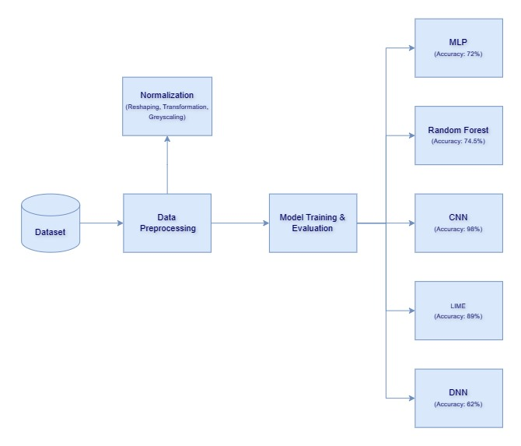

**3.1 Dataset Generation:** We created the dataset because it was not available, consisting of four cow diseases**.**  The dataset comprises images of cow diseases organized into four folders, each representing a specific disease: cows_mange, Lumpycows, cows_ringworm, and cows_pox. Additionally, there is one folder containing images of healthy cows.

*Data preprocessing:* It involves batch size determination, image resizing dimensions specification, color channel indication, and setting the number of epochs for training iterations.

### *Data Augmentation:* Data augmentation is employed to artificially increase the diversity of the dataset by applying various transformations to the original images.

*Model Evaluation:* Several convolutional and pooling layers are used to build a sequential model (model).The input photos are processed using convolutional layers with different filter sizes to extract features.In order to reduce computational complexity, the feature maps are downsampled using max pooling layers.

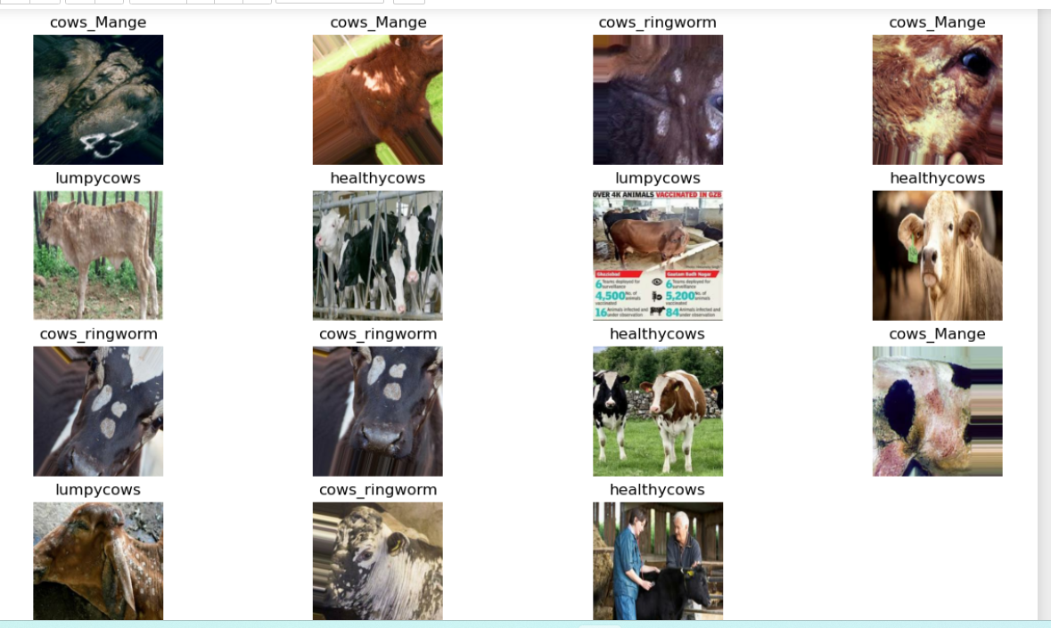

**3.2 Methodology**

The methodology for this study involves several steps. First, the images of cow diseases are loaded and pre-processed to ensure uniform dimensions and color channels. Next, the dataset is split into a training and testing set.

**Data Preprocessing**

Determines the number of samples that will be propagated through the network at a time during training.Specifies the dimensions to which the input images will be resized. Indicates the number of color channels in the images.Defines the number of times the entire dataset will be passed forward and backward through the neural network during training.

### **Data Augmentation**

Data augmentation is employed to artificially increase the diversity of the dataset by applying various transformations to the original images. This helps in improving the generalization ability of the model.

*40 augmented images are generated per original image.*

**Individual Image Visualization**

Each image in the dataset is iterated through, displayed, and its pixel values normalized.

### **Data Partitioning**

The dataset is divided into training, validation, and testing sets to facilitate model training, tuning, and evaluation, respectively.

#### **Splitting Training Sets:**80% of the dataset is the training set, which is a subset of the dataset.To extract the designated percentage of data for training, the take method is applied.

**Validation kept Splitting:** 10% of the remaining data is kept aside for validation once the training set is extracted, making up the validation set.The validation set is separated from the remaining data using the skip and take methods.

**Testing Set Splitting:** 10% of the whole dataset is identified as the testing set, which is the remaining portion not allocated for training or validation.The training and validation data are removed from the testing set using the skip approach.

**Shuffling (Optional):** If chosen, the dataset is shuffled to guarantee randomness and strengthen the resilience of the model.

A predetermined shuffle size and seed value are used when applying the shuffle method.

**Grad-CAM Visualization**

To improve model interpretability, significant regions in the input image that support the model's prediction are located using the Grad-CAM visualization technique.To interpret the predictions of the cow illness detection model, use the Grad-CAM visualization. Grad-CAM helps discover disease-related features and improves comprehension of the model's behavior by emphasizing the areas of the input image that are most important to the model's decision-making process.

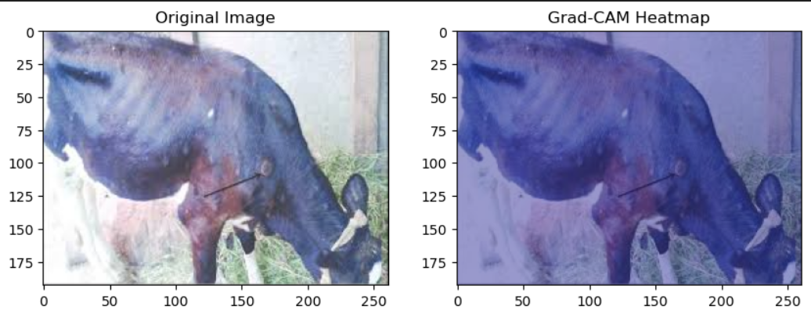

***Figure 3. After use of Grad Cam***

### **Grayscale Image Conversion**

This step's objective is to turn the RGB photos in the dataset into grayscale versions. By eliminating color information, grayscale photographs simplify the data representation, which can lower model complexity and increase computational performance.

**3.3 Model Evaluation**

Several convolutional and pooling layers are used to build a sequential model (model).The input photos are processed using convolutional layers with different filter sizes to extract features.In order to reduce computational complexity, the feature maps are downsampled using max pooling layers.

*Layers:* Flatten and Dense: A one-dimensional vector is created by flattening the feature maps.In order to do classification using the extracted characteristics, dense layers are created.The application of a ReLU activation function creates non-linearity in the buried

layers:

*Output Layer:* To generate probability scores for each class, a softmax activation function is applied to neurons in the output layer, which are equal in number to the number of classes.

To evaluate the model's performance, it is trained on the augmented training dataset and then tested on the validation and testing datasets. Accuracy metric, categorical cross-entropy loss function, and Adam optimizer are used to compile the model.

*Model Training:* Using the training dataset, the model is trained using the fit approach.

There are stated training parameters, including batch size, epoch count, and validation data.

*Model Evaluation:* The evaluate method is used to assess the trained model on the testing dataset.

*Function of Prediction:*

Using the trained model, a function called Predict is developed to generate predictions for specific photos.

To get predictions, the image is transformed into an array, normalized, and then run through the model.

Based on the projected class and confidence score, a on the highest probability.

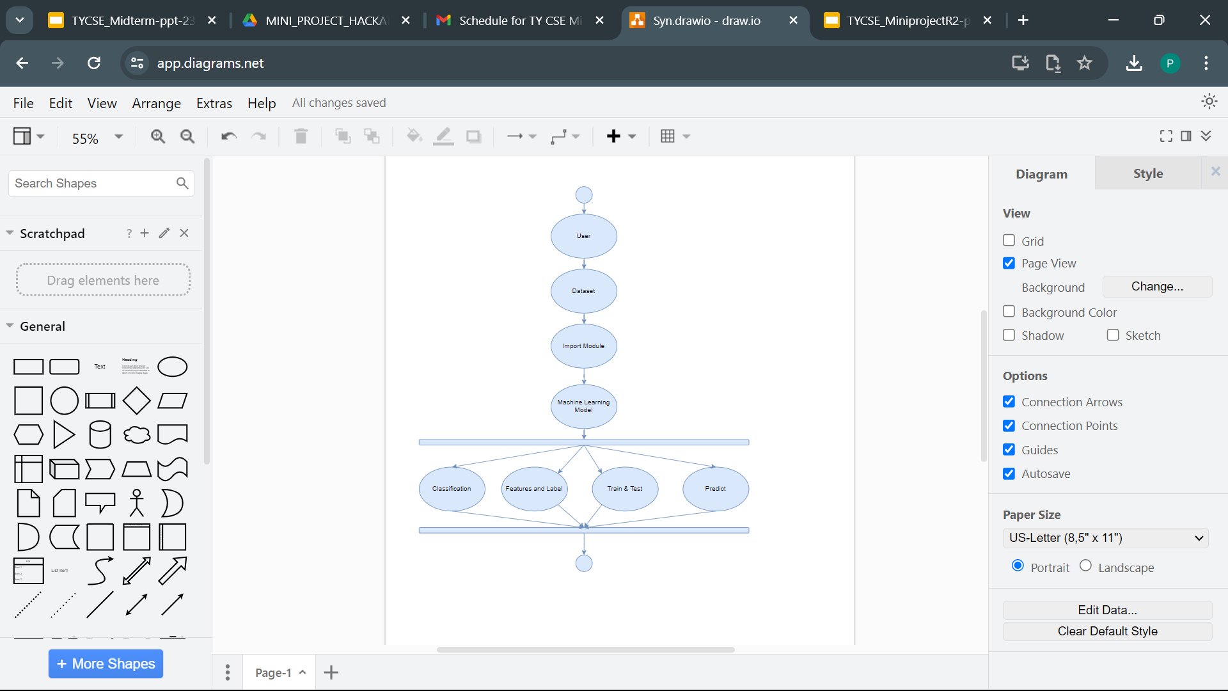

***Figure 4.1 UML Diagram***

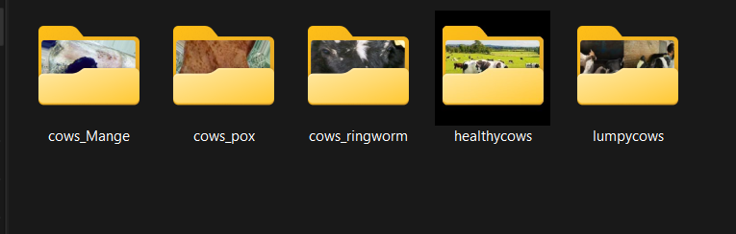

***Figure 4.2 Dataset***

**3.3 Algorithm**

### **Multi-Layer Perceptron (MLP) Classifier**

A feedforward neural network model called a Multi-Layer Perceptron (MLP) is made up of several layers of nodes, each of which is connected to the nodes in the layer below it. An input layer, one or more hidden layers, and an output layer make up its composition.

Input Layer: The input layer consists of nodes that represent the features of the input data.

Hidden Layers: The hidden layers are intermediary layers between the input and output layers. Each hidden layer contains multiple nodes (neurons) that perform transformations on the input data through weighted connections and activation functions.

Output Layer: The output layer produces the final predictions or classifications based on the processed information from the hidden layers.

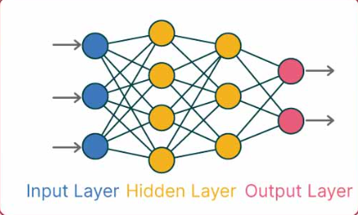

***Figure MLP***

### **Random Forest**

For classification and regression tasks, the ensemble learning technique Random Forest is employed. During training, it builds a large number of decision trees, and it produces a class that is the mean prediction (regression) or the mode of the classes (classification) of the individual trees.

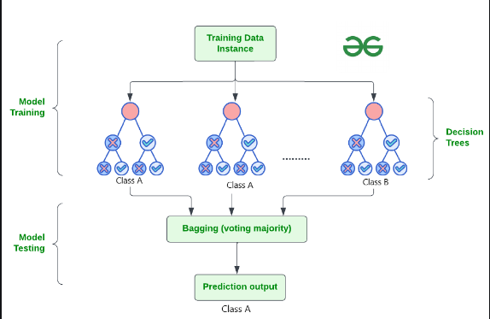

***Figure Random Forest***

**CNN**  
  
Convolutional Neural Network (CNN), a deep learning model that excels at picture classification tasks, is the algorithm utilized in the provided code. This is an explanation of CNN's operation. Using OpenCV (cv2), images are loaded from the dataset directory and preprocessed. Resizing photos to a standard size and normalizing pixel values to fall between [0, 1] are examples of preprocessing.Using the scikit-learn LabelEncoder, labels (disease classifications) are encoded into a numerical format. Class names encoded into numbers include 'cows_Mange', 'cows_pox', and so on.

The Keras Sequential API is used to define the CNN model architecture. It is composed of several layers: to extract features from input images, convolutional layers (Conv2D) with ReLU activation functions are used.

The offered code makes use of a deep learning model called Convolutional Neural Network (CNN), which is particularly good at photo classification jobs. Here's an explanation of how CNN works. Images are loaded from the dataset directory and preprocessed using OpenCV (cv2). Preprocessing includes things like resizing images to a standard size and standardizing pixel values to lie between [0, 1].Labels (disease categories) are encoded into a numerical representation using the scikit-learn. LabelEncoder. Class names like "cows_Mange," "cows_pox," and so on are encoded into integers.

The CNN model architecture is defined using the Keras Sequential API. It consists of many layers: convolutional layers (Conv2D) with ReLU activation functions are utilized to extract features from input images. Whatever is considered, CNNs are excellent at picture classification tasks because they automatically learn hierarchical representations of image information. This makes them a good choice for problems involving the detection of cattle diseases from image data.

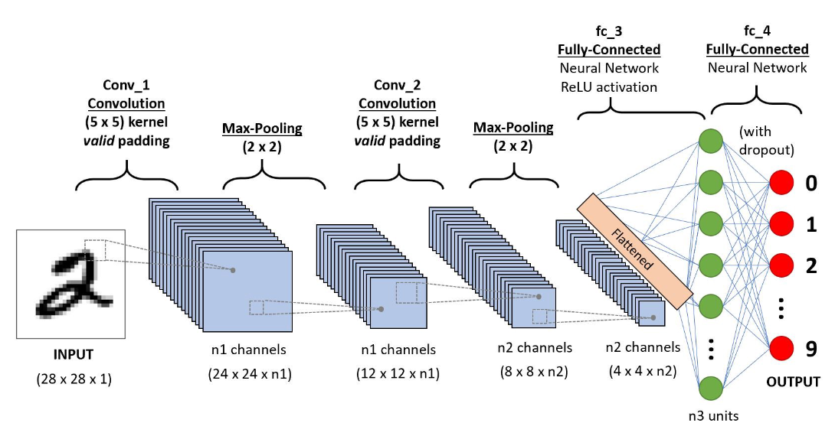

***Figure CNN***

**Lime**

The offered code employs a method known as Local Interpretable Model-agnostic Explanations (LIME). When it comes to image classification tasks in particular, machine learning models' predictions can be better understood using the explanation technique LIME.The goal of LIME is to give human-interpretable explanations for each unique prediction generated by deep neural networks and other sophisticated machine learning models.LIME provides an explanation of a model's forecast for a given image input in image classification tasks.By altering an input image and tracking the resulting modifications to the model's predictions, LIME produces an explanation for the image.It applies random noise or modifies the original image locally to sample a series of disturbed images.The predictions produced by a deep neural network model for image categorization that has already been trained are explained by LIME.

LIME produces an explanation for every sample image in the dataset by emphasizing the key areas of the image that affect the prediction made by the model.

The explanation is displayed as a heatmap superimposed on the original picture, highlighting the areas that influence the model's choice the most.

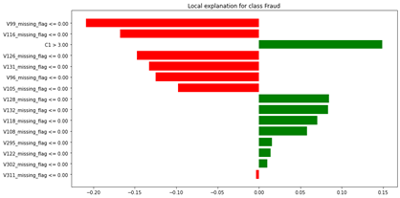

***Figure LIME***

**DNN**

Deep Neural Networks (DNNs) are neural networks with multiple hidden layers between the input and output layers.The depth of a network refers to the number of hidden layers it contains.DNNs are capable of learning complex patterns and representations from data due to their deep architecture.

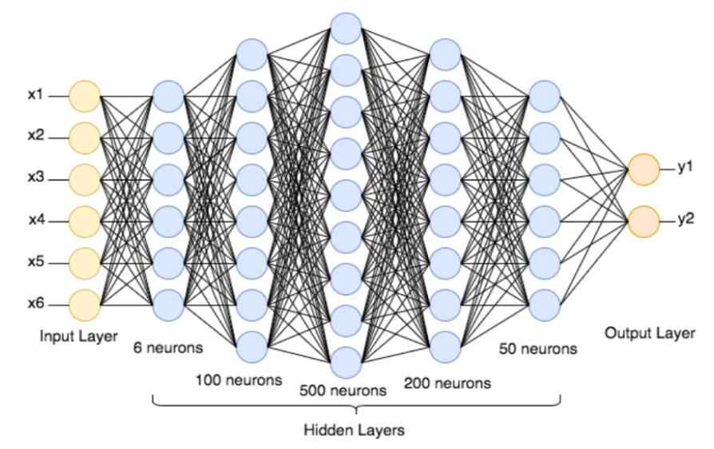

***Figure DNN***

**4. Result and Discussion**

Our empirical results show clear trends in the assessed models' performance. With respect to all measures, the CNN model performs exceptionally well, attaining high levels of accuracy, precision, recall, and F1-score. In a similar vein, the Random Forest model performs admirably, especially in terms of accuracy. The performance of the Multilayer Perceptron (MLP) and Deep Neural Network (DNN) models varies based on the features of the dataset, even though they produce moderate outcomes across the metrics. Furthermore, the interpretability study carried out with LIME improves our comprehension of the models' behavior by offering insightful information about the models' decision-making process.

| **Model** | **Precision** | **Recall** | **F1-Score** | **Accuracy** |
| --- | --- | --- | --- | --- |
| MLP | 65% | 57% | 61% | 72% |
| Random Forest | 73% | 62% | 73% | 74.49% |
| CNN | 98% | 98% | 98% | 98% |
| Lime | 89% | 89% | 89% | 89% |
| DNN | 62% | 62% | 62% | 62% |

***Table 1: Results of classifiers***

In this paper, several metrics are chosen to measure how well models perform such as, such as Accuracy, Precision, Recall, and F1 score.

These metrics are drawn from the following four categories: True Positives (TP): case where the true class of the instance was 1(True) and the model prediction is also 1 (True). False Positives (FP): a case where the true class of the instance was 0 (False) and the model prediction is 1 (True). True Negatives (TN): a case where the true class of the instance was 0 (False) and the model prediction is also 0 (False). False Negatives (FN): a case where the true class of the instance was 1 (True) and the model prediction is 0 (False).

**Accuracy –** accuracy measure described as the average number of correct predictions. However, this is not quite robust for the unbalanced dataset.

**𝐴𝑐𝑐𝑢𝑟𝑎𝑐𝑦 = 𝐶𝑜𝑟𝑟𝑒𝑐𝑡 𝑝𝑟𝑒𝑑𝑖𝑐𝑡𝑖𝑜𝑛 /𝑇𝑜𝑡𝑎𝑙 𝑝𝑟𝑒𝑑𝑖𝑐𝑡𝑖𝑜𝑛**

**Precision –** called positive predictive value measures the capability of a model to identify the correct instances for each class. This is a strong matrix for multi-class classification and unbalanced datasets.

**𝑃𝑟𝑒𝑐𝑖𝑠𝑖𝑜𝑛 = 𝑇𝑟𝑢𝑒 𝑃𝑜𝑠𝑖𝑡𝑖𝑣𝑒 (𝑇𝑟𝑢𝑒 𝑃𝑜𝑠𝑖𝑡𝑖𝑣𝑒 + 𝐹𝑎𝑙𝑠𝑒 𝑃𝑜𝑠𝑖𝑡𝑖𝑣𝑒)**

**Recall –** This metric measures a model’s performance in recognizing the true positive out of the total true positive cases.

**𝑅𝑒𝑐𝑎𝑙𝑙 = 𝑇𝑟𝑢𝑒 𝑃𝑜𝑠𝑖𝑡𝑖𝑣𝑒 (𝑇𝑟𝑢𝑒 𝑃𝑜𝑠𝑖𝑡𝑖𝑣𝑒 + 𝐹𝑎𝑙𝑠𝑒 𝑁𝑒𝑔𝑎𝑡𝑖𝑣𝑒)**

**F-score –** named as balanced F-score or F-measure. can be defined as a weighted average of precision and recall.

**𝐹 − 𝑠𝑐𝑜𝑟𝑒 = 2 ∗ (𝑃𝑟𝑒𝑐𝑖𝑠𝑖𝑜𝑛 ∗ 𝑅𝑒𝑐𝑎𝑙𝑙) (𝑃𝑟𝑒𝑐𝑖𝑠𝑖𝑜𝑛 + 𝑅𝑒𝑐𝑎𝑙𝑙)**

Based on experiments of implementing deep learning networks and a variety of classification machine learning algorithms to automatically detect Cow disease**.**

***Figure 4. Accuracy Comparison***

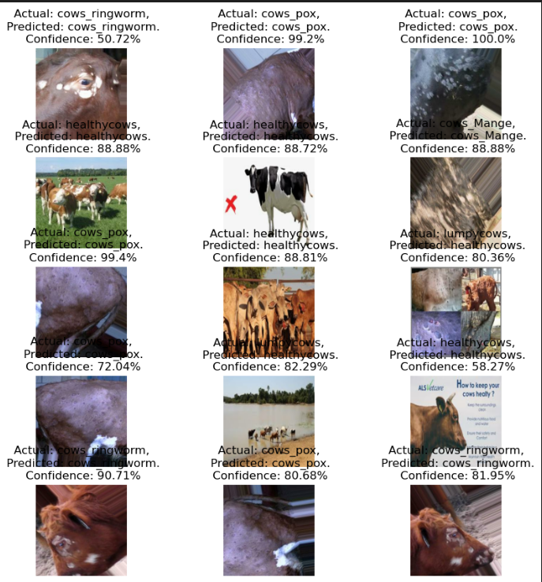

***Figure 6. Classification***

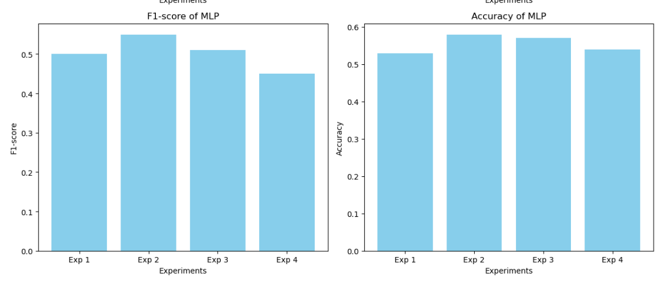

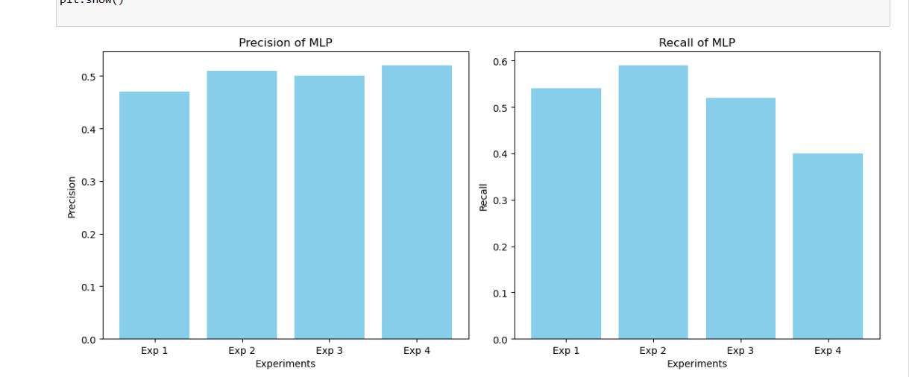

***7.1 Random Forest***

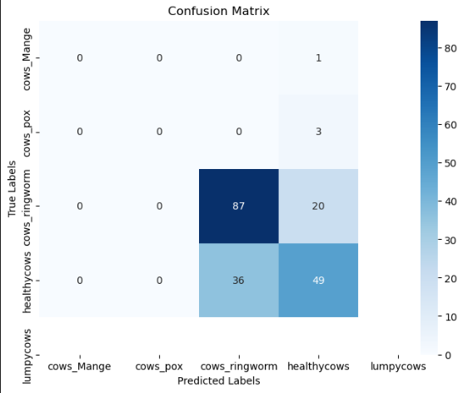

***The confusion matrix shows the classifier correctly identifies healthy cows but frequently misclassifies cows with mange, ringworm, or pox, indicating room for improvement in distinguishing similar conditions for the Random Forest Algorithm.***

***7.2.CNN***

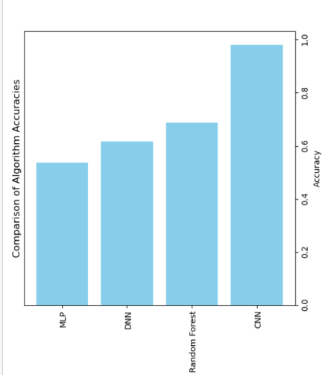

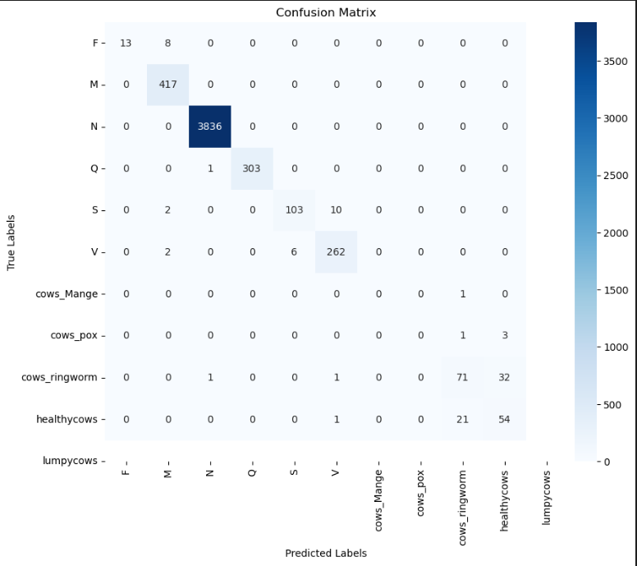

***The confusion matrix shows the classifier correctly identifies healthy cows but frequently misclassifies cows with mange, ringworm, or pox, indicating room for improvement in distinguishing similar conditions for the CNN algorithm.***

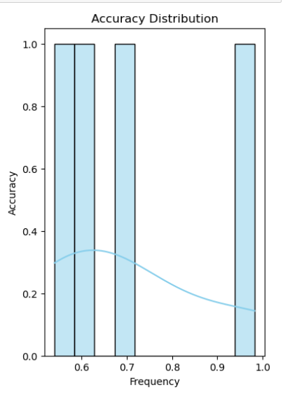

***7.3 DNN***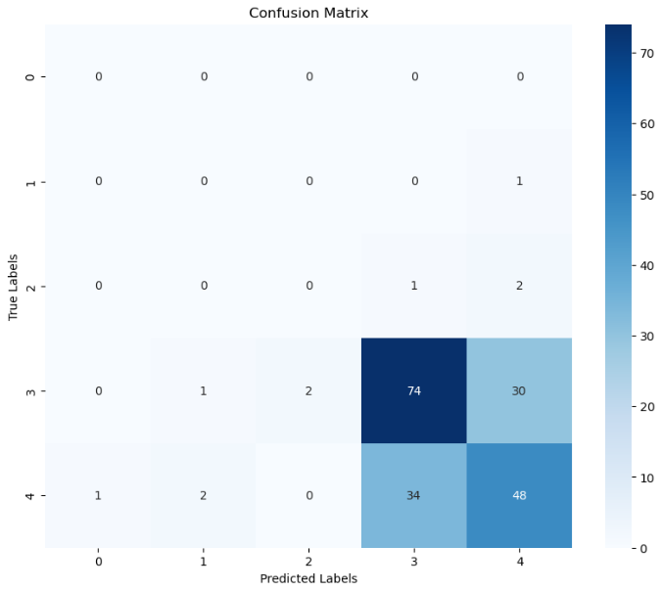

***The confusion matrix shows the classifier correctly identifies healthy cows but frequently misclassified cows with mange, ringworm, or pox, indicating room for improvement in distinguishing similar conditions for the DNN algorithm.***

***7.4 MLP***

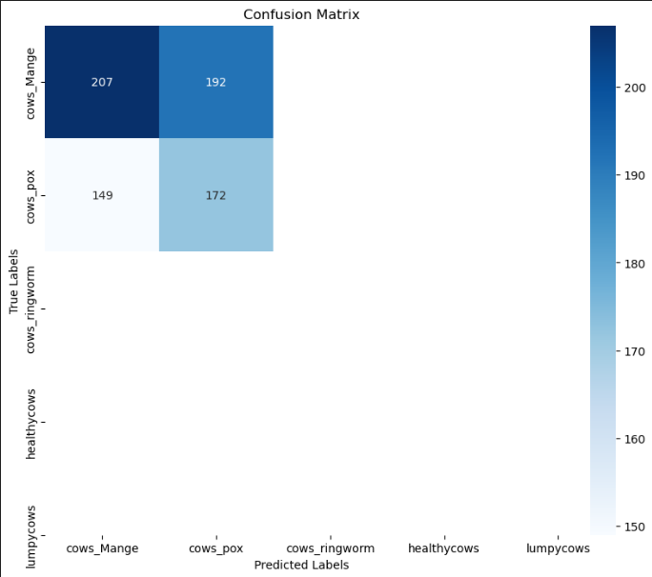

***The confusion matrix shows the classifier correctly identifies healthy cows but frequently misclassifies cows with mange, ringworm, or pox, indicating room for improvement in distinguishing similar conditions for the MLP algorithm.***

**5. Conclusion & Future Scope -**

The research described in this paper shows how machine learning and deep learning methods can be used to identify diseases in cows early on. Nonetheless, there are other domains that warrant additional investigation to enhance the precision and efficacy of the suggested structure. To provide a more complete picture of cow health, future studies may look into incorporating data from other sources, such as environmental data or sensor data from wearable technology. The creation of real-time monitoring systems that can notify farmers and veterinarians of possible health problems in their herds is another topic of interest. Furthermore, applying domain adaptation and transfer learning strategies may enhance the models' ability to be applied to various breeds and situations. Lastly, the application of explainable AI approaches may contribute to a decision-making process that is more transparent and trustworthy, facilitating the understanding and interpretation of the outcomes by farmers and veterinarians. All things considered, the use of deep learning and machine learning methods to the early diagnosis of cow illnesses holds great promise for enhancing animal welfare and lowering financial losses in the agriculture industry.

The paper offers an analytical and experimental inquiry into the use of machine learning (ML) approaches for early disease identification in cows. Early disease detection in cows has become a critical topic of research due to the growing demand for Cows products and the growing concern for animal welfare.

Data collection, preprocessing, feature selection, model construction, and evaluation were all part of the analytical strategy. The ML models were trained and validated through experimentation, yielding encouraging outcomes.

With the use of ML models, early disease identification in cows may be effectively addressed, improving animal welfare and minimizing financial losses for farmers. The practical applications of these models in real-world contexts should be the main emphasis of future research.

**5. REFERENCES**

[1]

H. I. Peyal et al., "Plant Disease Classifier: Detection of Dual-Crop Diseases Using Lightweight 2D CNN Architecture," in IEEE Access, vol. 11, pp. 110627-110643, 2023, doi: 10.1109/ACCESS.2023.3320686.

[2]

S. Hwang, H. K. Shin, J. M. Park, et al., “Classification of dog skin diseases using deep learning with images captured from multispectral imaging device,” Mol. Cell. Toxicol., vol. 18, pp. 299–309, 2022 1. DOI: 10.1007/s13273-022-00249-7.

[3]

A. Upadhyay, G. Singh, S. Mhatre, et al., “Dog Skin Diseases Detection and Identification Using Convolutional Neural Networks,” SN Comput. Sci., vol. 4, p. 250, 2023. DOI: 10.1007/s42979-022-01645-5.

[4]

Merrin Prasanna, N., Nagarau, C., Venkatesh, C., Subash Chandra Mouli, D., Riyazuddin, K., Rakesh Babu, B. (2024). Design and Development of Leaf Disease Detection Using the ML and Open CV for Tomato Plants. In: Kumar, A., Mozar, S. (eds) Proceedings of the 6th International Conference on Communications and Cyber Physical Engineering . ICCCE 2024. Lecture Notes in Electrical Engineering, vol 1096. Springer, Singapore. <https://doi.org/10.1007/978-981-99-7137-4_4>

[5]

Y. Zhang, C. Song and D. Zhang, "Deep Learning-Based Object Detection Improvement for Tomato Disease," in IEEE Access, vol. 8, pp. 56607-56614, 2020

[6]

K. Mridha, M. M. Uddin, J. Shin, S. Khadka and M. F. Mridha, "An Interpretable Skin Cancer Classification Using Optimized Convolutional Neural Network for a Smart Healthcare System," in IEEE Access, vol. 11, pp. 41003-41018, 2023

[7]

H. Al-Bashiri, O. Al-Hadhrami, A. Al-Areqi, M. Al-Rahmi, and S. Zeki. (2020). "A comprehensive review on automated disease diagnosis using artificial intelligence." Journal of Healthcare Engineering, vol. 2020, Article ID 2710472.

[8]

G. Yue, P. Wei, Y. Liu, Y. Luo, J. Du and T. Wang, "Automated Endoscopic Image Classification via Deep Neural Network With Class Imbalance Loss," in IEEE Transactions on Instrumentation and Measurement, vol. 72, pp. 1-11, 2023

[9]

B. Xi, J. Li, Y. Li, R. Song, W. Sun and Q. Du, "Multiscale Context-Aware Ensemble Deep KELM for Efficient Hyperspectral Image Classification," in IEEE Transactions on Geoscience and Remote Sensing, vol. 59, no. 6, pp. 5114-5130, June 2021

[10]

S. Kumar, M. K. Chaube and S. Kumar, "Secure and Sustainable Framework for Cattle Recognition Using Wireless Multimedia Networks and Machine Learning Techniques," in IEEE Transactions on Sustainable Computing, vol. 7, no. 3, pp. 696-708, 1 July-Sept. 2022

[11]

T. Al-Quraishi, J. H. Abawajy, N. Al-Quraishi, A. Abdalrada and L. Al-Omairi, "Predicting Breast Cancer Risk Using Subset of Genes," 2019 6th International Conference on Control, Decision and Information Technologies (CoDIT), Paris, France, 2019, pp. 1379-1384, doi: 10.1109/CoDIT.2019.8820378. keywords: {Breast cancer;Support vector machines;Gene expression;Predictive models;Feature extraction;Neural networks},

[12]

Md Ekramul Hossain, Muhammad Ashad Kabir, Lihong Zheng, Dave L. Swain, Shawn McGrath, Jonathan Medway,

A systematic review of machine learning techniques for cattle identification: Datasets, methods and future directions,

Artificial Intelligence in Agriculture, Volume 6, 2022, Pages 138-155, ISSN 2589-7217, <https://doi.org/10.1016/j.aiia.2022.09.002>.

[13]

Machuve, D., Nwankwo, E., Mduma, N., & Mbelwa, J. (2022). Poultry diseases diagnostics models using deep learning. Frontiers in Artificial Intelligence, 5, 733345.

[14]

Wang, Y., Kang, X., He, Z., Feng, Y., & Liu, G. (2022). Accurate detection of dairy cow mastitis with deep learning technology: A new and comprehensive detection method based on infrared thermal images. *animal*, *16*(10), 100646.

[15]

Lechler R. Sustaining Translational Research. Rambam Maimonides Med J. 2020 Oct 14;11(4):e0035. doi: 10.5041/RMMJ.10409. PMID: 32516111; PMCID: PMC7571437.

[16] <https://www.shiksha.com/online-courses/articles/understanding-multilayer-perceptron-mlp-neural-networks/>

[17]

<https://www.geeksforgeeks.org/random-forest-algorithm-in-machine-learning/>

[18]

<https://www.analyticsvidhya.com/blog/2020/10/what-is-the-convolutional-neural-network-architecture/>

[19]

<https://www.researchgate.net/figure/Deep-Neural-Network-architecture_fig1_330120030>